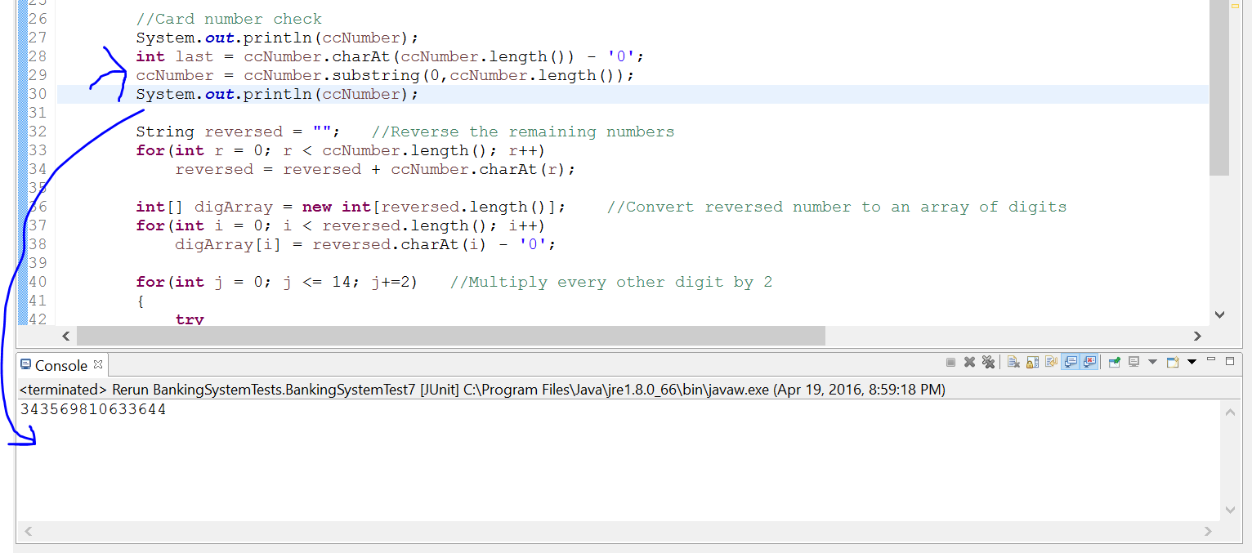

Line 29 deletes the credit card number

ccNumber = ccNumber.substring(0,ccNumber.length());

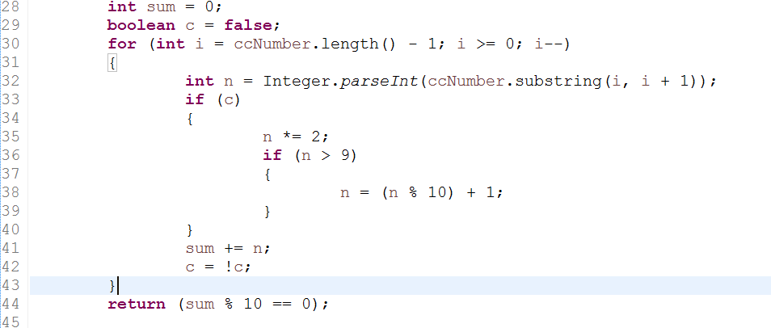

New code to authenticate credit card numbers